Lab 6: DNA (AT HOME)
-- Students will extract DNA from plant and animal samples

Module Objectives (MO):
- Identify the structures and organelles found in cells
- Describe the structure of a DNA molecule
Lab Objectives:
- Recognize structural differences in plant and animal cells
- Recognize the structural components of DNA
- Identify the role of various reagents in a DNA extraction protocol
- Perform the basic steps of DNA extraction

Materials/Supplies:
- 2 clean shot glasses or similarly-sized cups/bowls
- Detergent (liquid soap)
- Salt
- Contact lens cleaning solution or meat tenderizer
- Chilled alcohol (120 proof or higher, ex. rum) or isopropyl alcohol
- Baking dish (ex. 8x8 pan)
- Toothpicks (~15)
- Coffee filter or thick paper towel
- Saliva
- Strawberry

Description:
DNA is the hereditary information found in all living things, including bacteria, plants and animals. In eukaryotic organisms (like humans and plants), the DNA is contained within the nucleus and it is arranged into many long strands known as chromosomes. Isolation (i.e. extraction) of the DNA is a relatively simple process that involves a few basic steps. In this lab, you will extract DNA from two sources: you (in a saliva sample) and a strawberry.
Any photos, collected data, and conclusions should be recorded in the worksheet. You will be prompted to insert photos with this:

“Insert Photo Here”

Instructions
DNA extraction requires that a sample of living material be subjected to two main steps: lysis and precipitation. Because the cellular structure varies a little depending on the cell type and organism, the materials and specific steps taken to extract DNA will vary just a little bit among your samples. Additionally, a cleaning step to remove protein and other cellular debris may be included.
Lysis
Lysis is the breaking cells open of cells (and organelles) to release the DNA. In general, this step involves the use of detergents to destabilize the organization of a cell’s membranes (plasma membrane and also the nuclear envelope). These membranes are held together by hydrophobic interactions among the component phospholipids, and detergent/soap molecules interrupt these interactions. This causes the phospholipids to separate, and the internal components of the cell are released.
Animal cells (including human cells) are surrounded by a flexible covering called an extracellular matrix (ECM), while plant cells are surrounded by a rigid cell wall. The ECM can be easily disrupted using detergents, but the cell wall requires physical disruption (smashing or blending).

Procedure:
- Collect your saliva sample in a shot glass or other similarly-sized container. This is done by spitting into the shot glass. The saliva contains cells from your cheeks and mouth lining. Your goal is to collect saliva to fill approximately ½ of the shot glass (or approximately 1 tablespoon). It may help to work your tongue against your checks and teeth as you think about a delicious meal. Since these are animal cells and they are surrounded by a flexible outer covering, they will are now ready for the detergent (no physical disruption is needed).
- Place one small strawberry (or half of a strawberry) into the other shot glass or other similarly sized container. This contains plant cells and the rigid cell wall will require physical disruption. Use a fork or other instrument to mash the strawberry up as much as possible. It is now also ready for detergent.
- Add 1-2 drops of detergent to each container (both the saliva and strawberry). Use a toothpick to stir each sample. The detergent is separating the phospholipid structure of the membranes. As a result, the cellular contents are being released.
- Prepare a shallow baking dish with very warm water (should not be so hot that it is uncomfortable to the touch). Being careful that they do not tip over, place the two containers into the warm water. Incubate the containers in the prepared water bath for approximately 10 minutes. The warm temperature also helps with the disruption of the membrane structure.
THINK ABOUT
How does temperature enhance the disruption of the membranes?
It denatures the protein molecules that make up the cell membrane, which makes it easy for it to be dissociated by the soap detergent and other reagents used.
- Remove the containers from the warm water and allow them to cool to room temperature.
- Insert a picture of your two samples here:

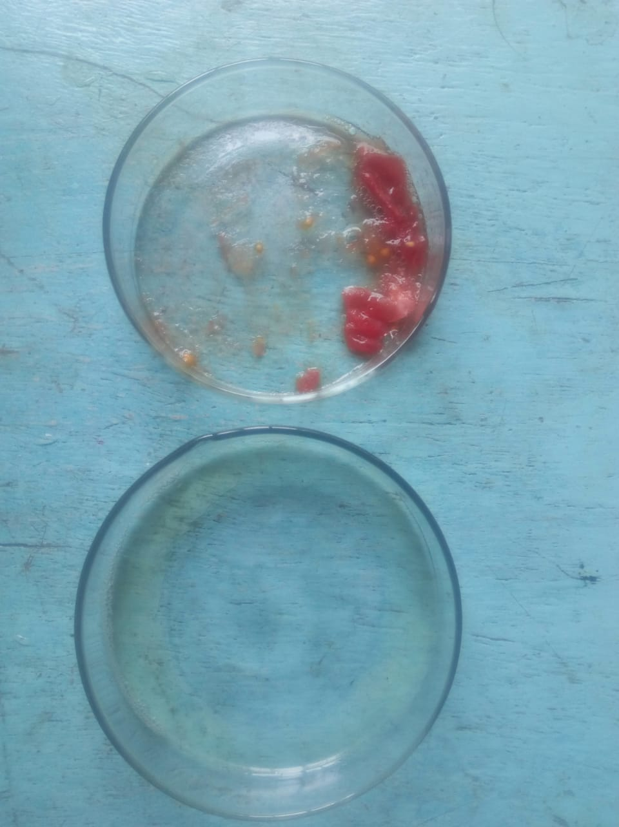

Cleaning (removal of protein contamination)
- Now that the cellular contents have been released from the cell, you will separate the liquid from the cellular debris. This is only needed for the strawberry sample.
THINK ABOUT
Why is it unnecessary to filter the saliva sample?
It does not contain debris that would hinder the visibility of DNA strands

- Using a coffee filter or a thick paper towel, attempt to strain the strawberry liquid into a fresh container. You can discard the filtered out debris.
- Next, you will remove some of the contaminating proteins from the released DNA. This will be accomplished using either contact lens cleaner or meat tenderizer. These contain protease enzymes that will digest or break down proteins.
- Add a few drops of contact lens cleaner or a tiny amount of meat tenderizer powder to both the strawberry and saliva samples. Stir the samples briefly using a clean toothpick.
- Insert a picture of your two samples here:

Insert Photo Here
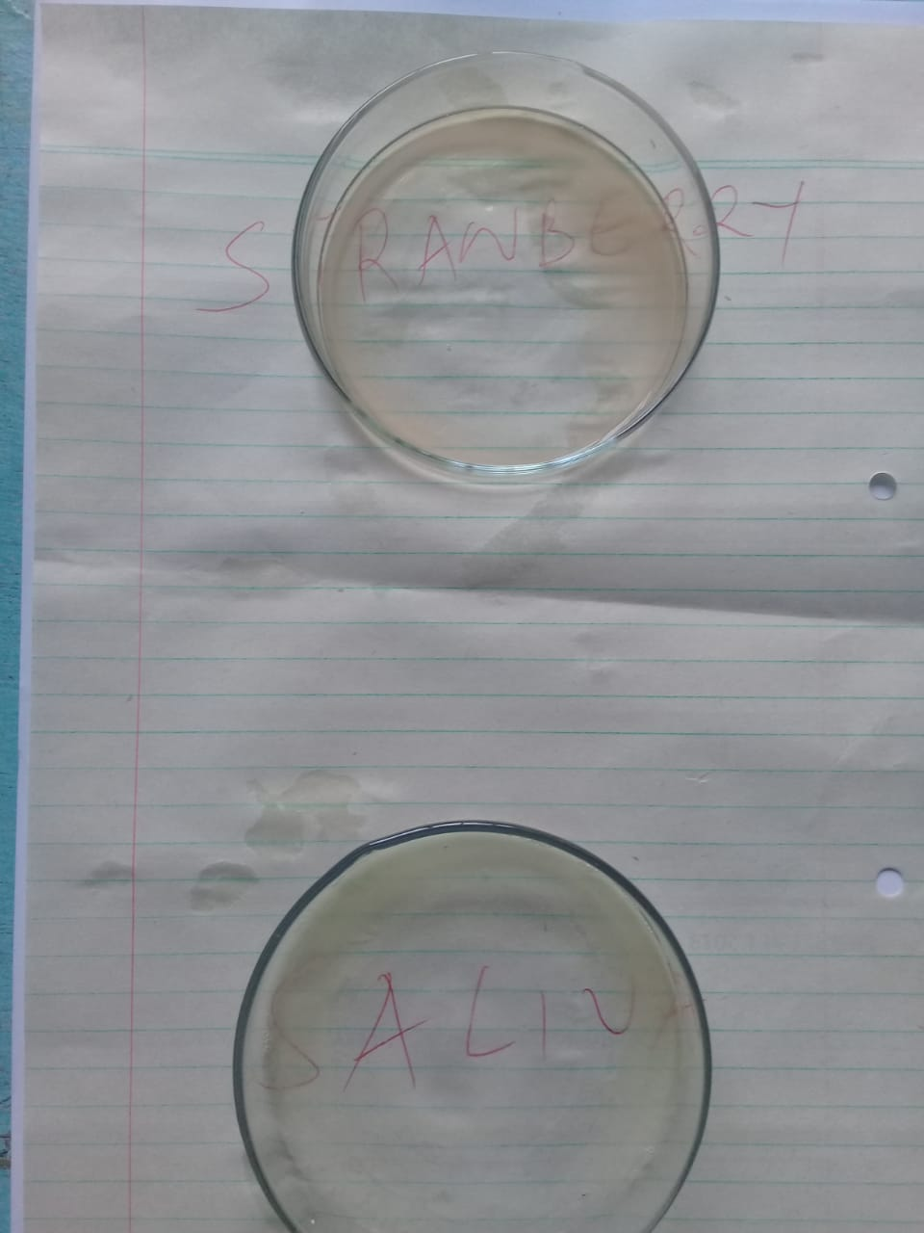
Precipitation (removing the DNA from solution)
- Add a pinch of salt to each of the containers. Mix gently with a clean toothpick. The DNA molecule is negatively-charged because of the many phosphate groups. The negative charge will be attracted to the positively-charged sodium ion. This interaction between the negative DNA and the positive sodium will cause the DNA molecules to start clumping together.
- Gently add enough chilled alcohol to fill the container. Stir very gently using a clean toothpick. The DNA is not soluble in alcohol, so it will begin to precipitate as the solution and ethanol combine.
- Gently swirl the toothpick in the solution and attempt to spool up (i.e. lift up or remove) the cloudy, slimy material that has formed. This is the DNA.
- Insert a picture of your two spooled DNA samples here:

Insert Photo Here

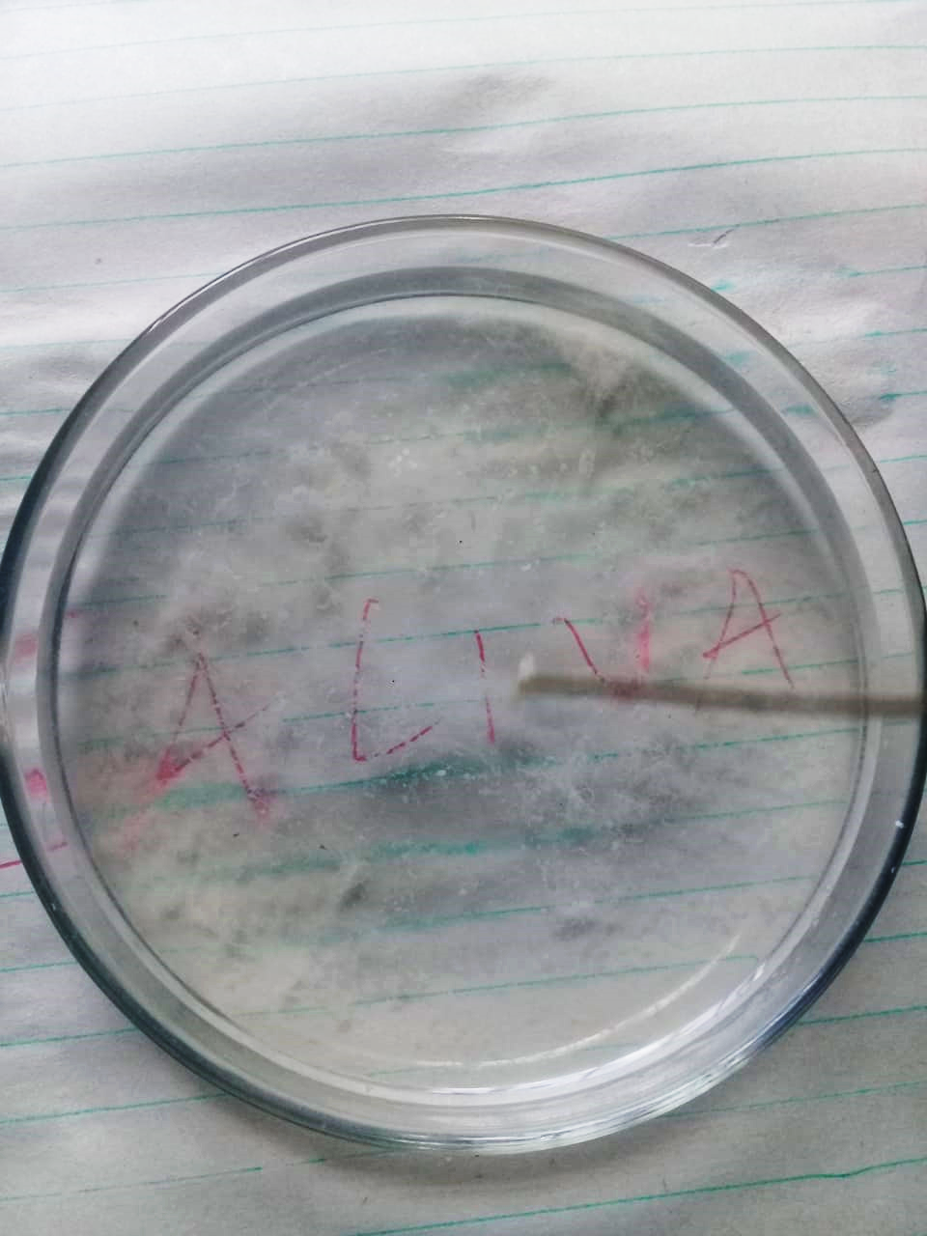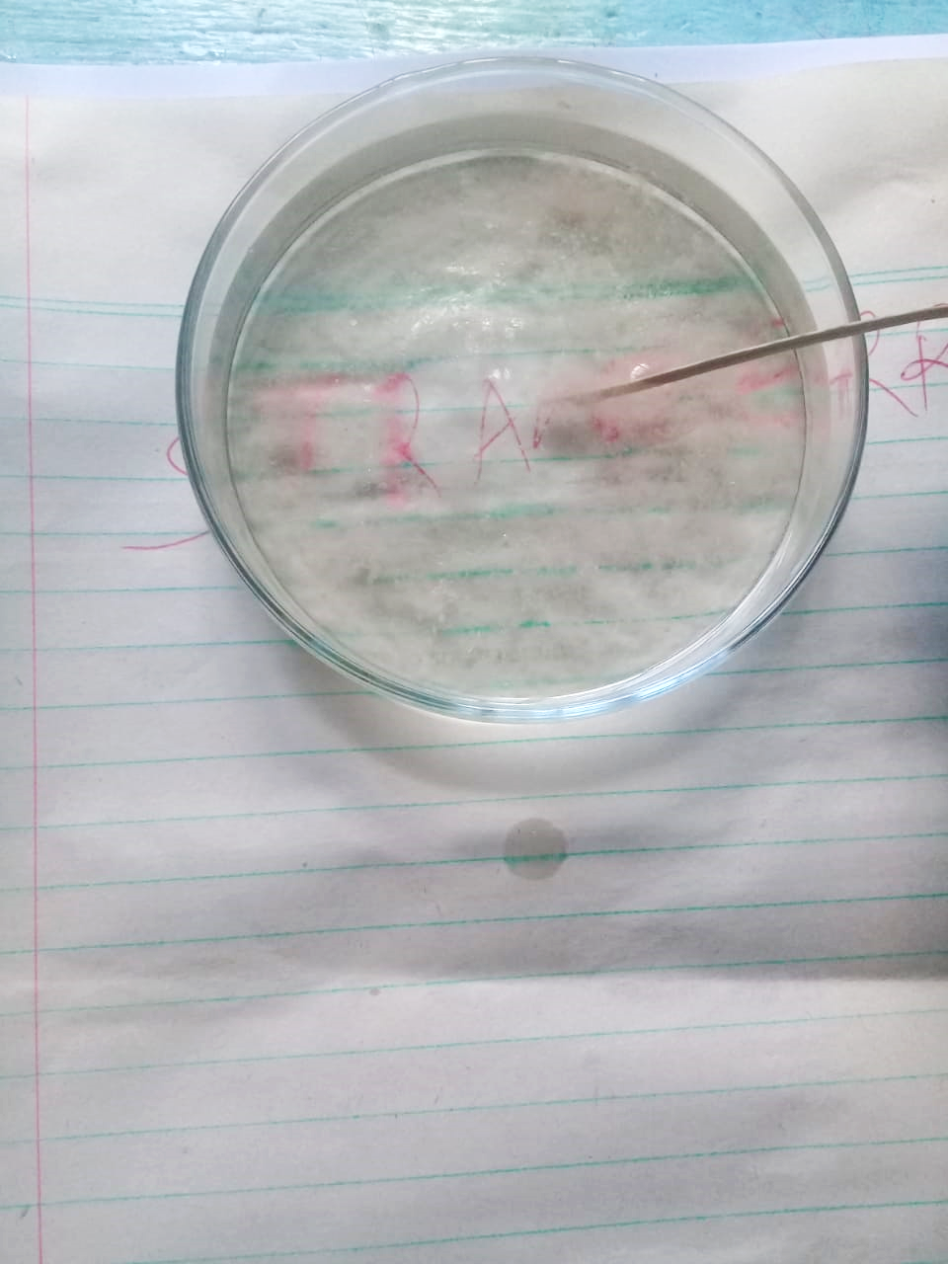

Questions for further thought:
- Describe the overall structure of DNA. In your description, explain what parts of the molecule played a specific role in this extraction protocol.
The DNA is made up of is made up of different components, which include phospholipid and nitrogenous molecules. The molecules are consolidated to form strands (chromatids) that contain the genes, which could not be viewed using the procedures that were undertaken during the practical. The phospholipid and nitrogenous molecules played a critical role in the extraction process.
- Describe how the cellular membranes were disrupted in this process.
The soap detergent disorganized the phospholipid layer of the cells while the incubation process denatured the plasmamebrane, which released the nucleus that contains the DNA. After the DNA was released, the meat tenderizer removed contaminating proteins from the DNA and the salt attracted the negatively charged DNA molecules that were then precipitated using the alcohol (isopropyl).
- DNA extraction from plant cells can be more difficult than DNA extraction from animal cells. Explain why this might be the case.
Plant cells have cellulose cell walls that is hard to break, which hinders the interaction of the nucleus with the reagents.
- Does all food have DNA in it? Explain your reasoning.
Yes because all food is drawn from plant and animal cells, which contain DNA.
- Besides strawberry and saliva, suggest one additional plant material and one additional animal material that might be a good (and ethical) source of material for a DNA extraction protocol such as this.
Plant—tomato fruit
Animal—blood sample

